|  |  |  |
| --- | --- | --- |
| **Electrical Applications** | Instructor Verified: |  |
| **Hands On Test #1** |  |  |
| **Switching Circuit with Duplex** | Grade: |  |

Name: ___________________________________ Date ___________________

**Materials:**

|  |  |
| --- | --- |
| **Materials Provided by You** | **Materials Provided by the Dept.** |
| 1. Necessary Tools | 1. 4 x 4 Metal Boxes |
| 2. 14/2 w/Ground NM-B | 2. Romex Connectors |
| 3. Wire Nuts |  |
| 4. Luminary Socket |  |
| 5. Single Pole, Single Throw Switch |  |
| 6. Duplex Receptacle |  |
| 7. Grounding Strap(s) |  |

**Objective:**

Given the necessary materials, the student will construct an electrical circuit to the specifications listed, as evidenced by scoring a minimum of 75% on this hands on test.

**Description of the Circuit:**

Construct a circuit in which power is fed to a duplex box, then to a single pole switch box that controls a third luminary box. The switch controls the light only. The duplex shall maintain power regardless of the switch position. All devices are installed in metal boxes. Use grounding straps where appropriate.

**Construct the circuit.**

|  |  |  |
| --- | --- | --- |
| Description | Pts | Score |
| Circuit wired correctly | 5 |  |
| 6” of free conductor from the front edge of the box | 5 |  |
| Wire nut connections secure. | 5 |  |
| Conductors affixed on device correctly | 5 |  |
| 1/4” cable sheath inside box. | 5 |  |
| All current carrying conductors insulation un-marred | 5 |  |
| Circuit works as described. | 20 |  |

**Instructor’s Notes:**

**Part 1 (+50 points):**

Using a straight edge, draw the circuit described above. Five points will be deducted for each error.

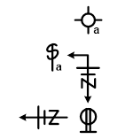

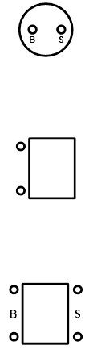

Hands On Test # 1